MySQL Capstone Project

RetailSphere E-Commerce Analytics Platform

PROJECT SPECIFICATIONS & WORKBOOK

Project Scenario
RetailSphere is a growing E-commerce company that sells Electronics, Fashion, Home Appliances, and Accessories across multiple cities.
The company wants to build a centralized MySQL database system to:
- Manage Customers
- Manage Products
- Track Orders
- Monitor Inventory
- Analyze Sales
- Generate Business Reports
- Improve Query Performance
Students are expected to design, populate, query, and optimize the database using MySQL.
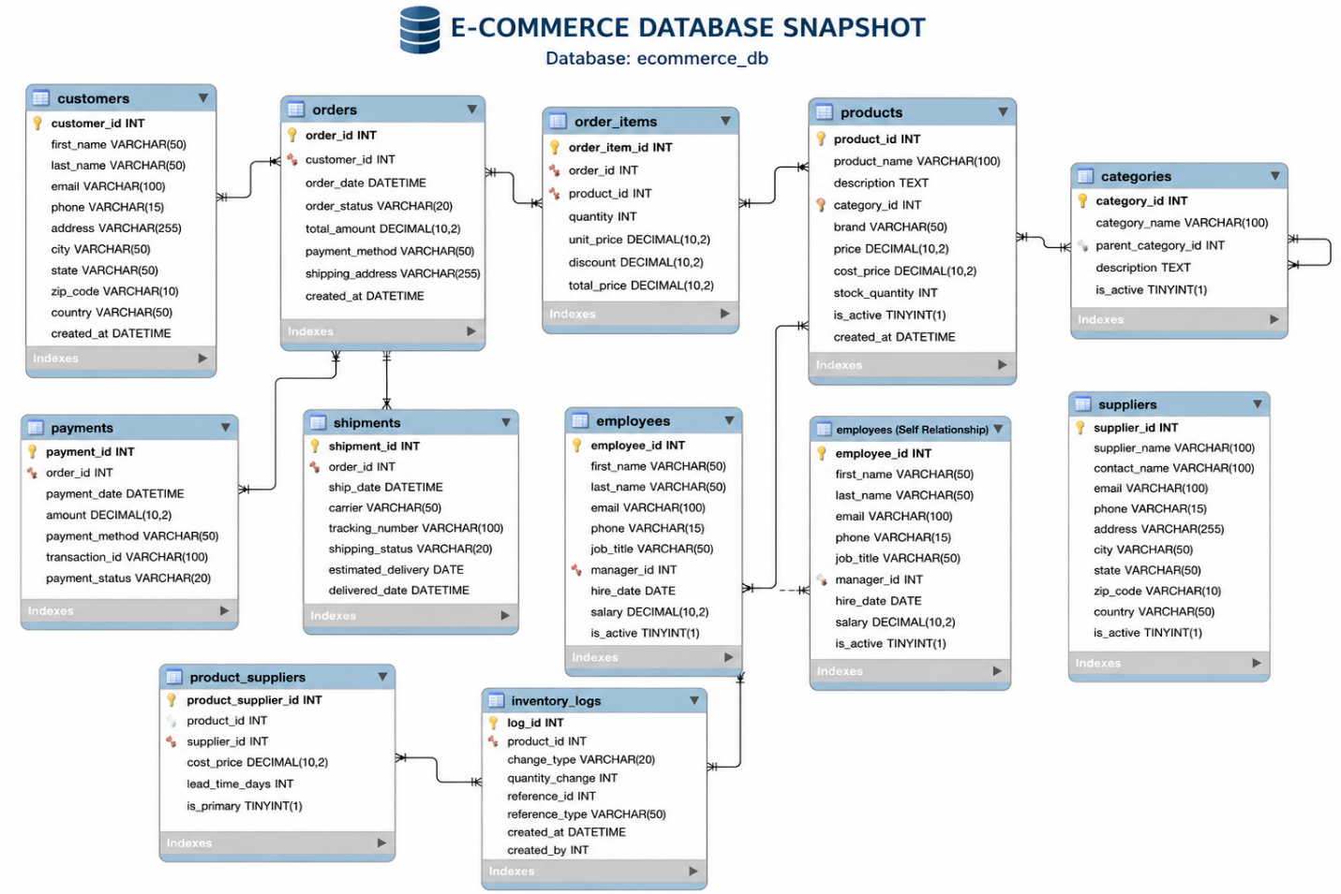

Phase 1 – Database Design

Database Creation
CREATE DATABASE retailsphere_db;
USE retailsphere_db;

Table 1 – Customers
Column | Data Type | Constraints
customer_id | INT | PRIMARY KEY
first_name | VARCHAR(50) | NOT NULL
last_name | VARCHAR(50) | NOT NULL
email | VARCHAR(100) | UNIQUE
city | VARCHAR(50) | NOT NULL
registration_date | DATE | DEFAULT CURRENT_DATE
CREATE TABLE customers (
customer_id INT PRIMARY KEY,
first_name VARCHAR(50) NOT NULL,
last_name VARCHAR(50) NOT NULL,
email VARCHAR(100) UNIQUE,
city VARCHAR(50) NOT NULL,
registration_date DATE DEFAULT (CURRENT_DATE)
);

Table 2 – Categories
Column | Data Type | Constraints
category_id | INT | PRIMARY KEY
category_name | VARCHAR(50) | UNIQUE
CREATE TABLE categories (
category_id INT PRIMARY KEY,
category_name VARCHAR(50) UNIQUE
);

Table 3 – Products
Column | Data Type | Constraints
product_id | INT | PRIMARY KEY
product_name | VARCHAR(100) | NOT NULL
category_id | INT | FOREIGN KEY
price | DECIMAL(10,2) | CHECK(price > 0)
stock_quantity | INT | DEFAULT 0
CREATE TABLE products (
product_id INT PRIMARY KEY,
product_name VARCHAR(100) NOT NULL,
category_id INT,
price DECIMAL(10,2) CHECK(price > 0),
stock_quantity INT DEFAULT 0,
FOREIGN KEY(category_id) REFERENCES categories(category_id)
);

Table 4 – Orders
Column | Data Type | Constraints
order_id | INT | PRIMARY KEY
customer_id | INT | FOREIGN KEY
order_date | DATE | NOT NULL
order_status | VARCHAR(30) | DEFAULT ‘Processing’
CREATE TABLE orders (
order_id INT PRIMARY KEY,
customer_id INT,
order_date DATE NOT NULL,
order_status VARCHAR(30) DEFAULT 'Processing',
FOREIGN KEY(customer_id) REFERENCES customers(customer_id)
);

Table 5 – Order_Items
Column | Data Type | Constraints
order_item_id | INT | PRIMARY KEY
order_id | INT | FOREIGN KEY
product_id | INT | FOREIGN KEY
quantity | INT | CHECK(quantity > 0)
unit_price | DECIMAL(10,2) | NOT NULL
CREATE TABLE order_items (
order_item_id INT PRIMARY KEY,
order_id INT,
product_id INT,
quantity INT CHECK(quantity > 0),
unit_price DECIMAL(10,2) NOT NULL,
FOREIGN KEY(order_id) REFERENCES orders(order_id),
FOREIGN KEY(product_id) REFERENCES products(product_id)
);

Table 6 – Suppliers
Column | Data Type | Constraints
supplier_id | INT | PRIMARY KEY
supplier_name | VARCHAR(100) | NOT NULL
city | VARCHAR(50) | NOT NULL
CREATE TABLE suppliers (
supplier_id INT PRIMARY KEY,
supplier_name VARCHAR(100) NOT NULL,
city VARCHAR(50) NOT NULL
);

Table 7 – Product_Suppliers
Column | Data Type | Constraints
supplier_id | INT | FOREIGN KEY
product_id | INT | FOREIGN KEY
CREATE TABLE product_suppliers (
supplier_id INT,
product_id INT,
FOREIGN KEY(supplier_id) REFERENCES suppliers(supplier_id),
FOREIGN KEY(product_id) REFERENCES products(product_id)
);

Phase 2 – Data Population

Insert Categories
INSERT INTO categories VALUES
(1, 'Electronics'),
(2, 'Fashion'),
(3, 'Home Appliances');

Insert Customers
INSERT INTO customers VALUES
(101, 'Arun', 'Kumar', 'arun@gmail.com', 'Chennai', '2025-01-10'),
(102, 'Meena', 'Raj', 'meena@gmail.com', 'Bangalore', '2025-02-15'),
(103, 'John', 'David', 'john@gmail.com', 'Hyderabad', '2025-03-20'),
(104, 'Sita', 'Rao', 'sita@gmail.com', 'Mumbai', '2025-04-01');

Insert Products
INSERT INTO products VALUES
(201, 'Laptop', 1, 75000, 20),
(202, 'Mobile', 1, 30000, 50),
(203, 'T-Shirt', 2, 1500, 100),
(204, 'Washing Machine', 3, 25000, 10),
(205, 'Headphones', 1, 2000, 40);

Insert Orders
INSERT INTO orders VALUES
(301, 101, '2025-05-01', 'Delivered'),
(302, 102, '2025-05-03', 'Processing'),
(303, 103, '2025-05-05', 'Delivered'),
(304, 101, '2025-05-07', 'Cancelled');

Insert Order Items
INSERT INTO order_items VALUES
(1, 301, 201, 1, 75000),
(2, 301, 205, 2, 2000),
(3, 302, 203, 3, 1500),
(4, 303, 202, 1, 30000),
(5, 304, 204, 1, 25000);

Insert Suppliers
INSERT INTO suppliers VALUES
(401, 'Tech Distributors', 'Chennai'),
(402, 'Fashion Hub', 'Delhi'),
(403, 'Appliance World', 'Mumbai');

Insert Product Suppliers
INSERT INTO product_suppliers VALUES
(401, 201),
(401, 202),
(402, 203),
(403, 204),
(401, 205);

Phase 3 – Business Tasks

Basic Queries
- Show all customers.
- Show product names and prices.
- Find customers from Chennai.
- Display products with price greater than 20000.
- Sort products by price descending.
- Show top 3 expensive products.
- Find unique cities from customers table.
- Update stock quantity for a product.
- Delete cancelled orders.
- Find products between 2000 and 50000.

Aggregate Functions
- Find total number of customers.
- Find average product price.
- Find maximum product price.
- Find minimum product price.
- Find total revenue generated.
- Find category-wise average product price.
- Find products count per category.
- Find categories with average price greater than 10000.

Joins
- Show customer names with their orders.
- Show products and categories using INNER JOIN.
- Show all customers even if they have no orders.
- Show all orders even if customer details are missing.
- Show every customer-product combination using CROSS JOIN.
- Create an employee-manager style SELF JOIN example.
- Show supplier names with supplied products.

Subqueries
- Find products priced above average price.
- Find customers who placed orders using EXISTS.
- Find products with price greater than ALL Fashion products.
- Find products with price greater than ANY Electronics products.

Advanced SQL
- Categorize products using CASE statement.
- Create a Finance View for sales reporting.
- Create a Stored Procedure to insert orders.
- Create indexes for performance optimization.
- Create a report showing top-selling products.
- Create a view for customer order summary.

Solution

Task 1 – Show All Customers
SELECT * FROM customers;

Why this works
Retrieves every column and every row from customers table.

Learning Checkpoint
Basic table scan query.

Task 2 – Product Names and Prices
SELECT product_name, price
FROM products;

Why this works
Retrieves selected columns instead of entire table.

Learning Checkpoint
Column-level projection improves readability.

Task 3 – Customers from Chennai
SELECT * FROM customers
WHERE city = 'Chennai';

Why this works
WHERE filters rows before result generation.

Task 4 – Products Price Greater Than 20000
SELECT * FROM products
WHERE price > 20000;

Task 5 – Sort Products by Price Descending
SELECT * FROM products
ORDER BY price DESC;

Why this works
ORDER BY sorts rows after filtering.

Task 6 – Top 3 Expensive Products
SELECT * FROM products
ORDER BY price DESC
LIMIT 3;

Learning Checkpoint
LIMIT improves reporting efficiency.

Task 7 – Unique Cities
SELECT DISTINCT city
FROM customers;

Task 8 – Update Stock Quantity
UPDATE products
SET stock_quantity = 60
WHERE product_id = 202;

Task 9 – Delete Cancelled Orders
DELETE FROM orders
WHERE order_status = 'Cancelled';

Task 10 – Products Between Range
SELECT * FROM products
WHERE price BETWEEN 2000 AND 50000;

Task 11 – Total Customers
SELECT COUNT(*) AS total_customers
FROM customers;

Task 12 – Average Product Price
SELECT AVG(price) AS average_price
FROM products;

Task 13 – Maximum Product Price
SELECT MAX(price) AS max_price
FROM products;

Task 14 – Minimum Product Price
SELECT MIN(price) AS min_price
FROM products;

Task 15 – Total Revenue
SELECT SUM(quantity * unit_price) AS total_revenue
FROM order_items;

Why this works
Revenue = quantity × price.

Task 16 – Category Wise Average Price
SELECT c.category_name,
AVG(p.price) AS avg_price
FROM products p
INNER JOIN categories c
ON p.category_id = c.category_id
GROUP BY c.category_name;

Why INNER JOIN?
Every product must belong to valid category.

Task 17 – Product Count Per Category
SELECT c.category_name,
COUNT(p.product_id) AS total_products
FROM categories c
LEFT JOIN products p
ON c.category_id = p.category_id
GROUP BY c.category_name;

Why LEFT JOIN?
Shows categories even without products.

Task 18 – Categories With Avg Price > 10000
SELECT c.category_name,
AVG(p.price) AS avg_price
FROM products p
INNER JOIN categories c
ON p.category_id = c.category_id
GROUP BY c.category_name
HAVING AVG(p.price) > 10000;

Task 19 – Customer Names With Orders
SELECT c.first_name,
o.order_id,
o.order_date
FROM customers c
INNER JOIN orders o
ON c.customer_id = o.customer_id;

Task 20 – Products and Categories
SELECT p.product_name,
c.category_name
FROM products p
INNER JOIN categories c
ON p.category_id = c.category_id;

Task 21 – All Customers Even Without Orders
SELECT c.first_name,
o.order_id
FROM customers c
LEFT JOIN orders o
ON c.customer_id = o.customer_id;

Why LEFT JOIN?
Retains all customers.

Task 22 – All Orders Even Without Customers
SELECT o.order_id,
c.first_name
FROM customers c
RIGHT JOIN orders o
ON c.customer_id = o.customer_id;

Task 23 – Cross Join
SELECT c.first_name,
p.product_name
FROM customers c
CROSS JOIN products p;

Learning Checkpoint
Produces Cartesian product.

Task 24 – Self Join
CREATE TABLE employees (
emp_id INT PRIMARY KEY,
emp_name VARCHAR(50),
manager_id INT
);
INSERT INTO employees VALUES
(1, 'Arun', NULL),
(2, 'Meena', 1),
(3, 'Raj', 1);
SELECT e.emp_name AS employee,
m.emp_name AS manager
FROM employees e
LEFT JOIN employees m
ON e.manager_id = m.emp_id;

Task 25 – Supplier Names With Products
SELECT s.supplier_name,
p.product_name
FROM suppliers s
INNER JOIN product_suppliers ps
ON s.supplier_id = ps.supplier_id
INNER JOIN products p
ON ps.product_id = p.product_id;

Task 26 – Products Above Average Price
SELECT * FROM products
WHERE price > (
SELECT AVG(price)
FROM products
);

Task 27 – Customers Who Placed Orders
SELECT * FROM customers c
WHERE EXISTS (
SELECT 1
FROM orders o
WHERE o.customer_id = c.customer_id
);

Why EXISTS?
Efficient existence checking.

Task 28 – Products Greater Than ALL Fashion Products
SELECT * FROM products
WHERE price > ALL (
SELECT price
FROM products p
INNER JOIN categories c
ON p.category_id = c.category_id
WHERE c.category_name = 'Fashion'
);

Task 29 – Products Greater Than ANY Electronics Products
SELECT * FROM products
WHERE price > ANY (
SELECT price
FROM products p
INNER JOIN categories c
ON p.category_id = c.category_id
WHERE c.category_name = 'Electronics'
);

Task 30 – CASE Statement
SELECT product_name,
price,
CASE
WHEN price >= 50000 THEN 'Premium'
WHEN price >= 10000 THEN 'Mid Range'
ELSE 'Budget'
END AS product_category
FROM products;

Task 31 – Finance View
CREATE VIEW finance_report AS
SELECT o.order_id,
c.first_name,
p.product_name,
oi.quantity,
oi.unit_price,
(oi.quantity * oi.unit_price) AS total_amount
FROM orders o
INNER JOIN customers c
ON o.customer_id = c.customer_id
INNER JOIN order_items oi
ON o.order_id = oi.order_id
INNER JOIN products p
ON oi.product_id = p.product_id;

Why Views?
Simplifies repeated reporting queries.

Task 32 – Stored Procedure
DELIMITER //
CREATE PROCEDURE add_new_order(
IN p_order_id INT,
IN p_customer_id INT,
IN p_order_date DATE,
IN p_status VARCHAR(30)
)
BEGIN
INSERT INTO orders
VALUES(p_order_id, p_customer_id, p_order_date, p_status);
END //
DELIMITER ;

Why Stored Procedure?
Reusable business logic.

Task 33 – Create Indexes
CREATE INDEX idx_product_name
ON products(product_name);
CREATE INDEX idx_customer_city
ON customers(city);

Learning Checkpoint
Indexes reduce search complexity from full scan toward logarithmic lookup.

Task 34 – Top Selling Products
SELECT p.product_name,
SUM(oi.quantity) AS total_sold
FROM products p
INNER JOIN order_items oi
ON p.product_id = oi.product_id
GROUP BY p.product_name
ORDER BY total_sold DESC;

Task 35 – Customer Order Summary View
CREATE VIEW customer_order_summary AS
SELECT c.customer_id,
c.first_name,
COUNT(o.order_id) AS total_orders
FROM customers c
LEFT JOIN orders o
ON c.customer_id = o.customer_id
GROUP BY c.customer_id, c.first_name;

Final Notes
This project simulates a real-world E-commerce analytics platform where:
- Customers place orders
- Products belong to categories
- Suppliers manage inventory
- Finance teams use Views
- Backend systems use Stored Procedures
- Database performance is improved using Indexes
By completing this project, students will gain practical exposure to:
- Relational database design
- Query optimization
- Business analytics reporting
- Real-world SQL development
- End-to-end MySQL workflow

